American Culinary Federation
Flint-Saginaw Valley Chapter
Presents
Our 34th Annual Professional Chefs’ Competition & Tasting
“Blue Ribbons & Bold Flavors”
A County Fair Culinary Showdown!
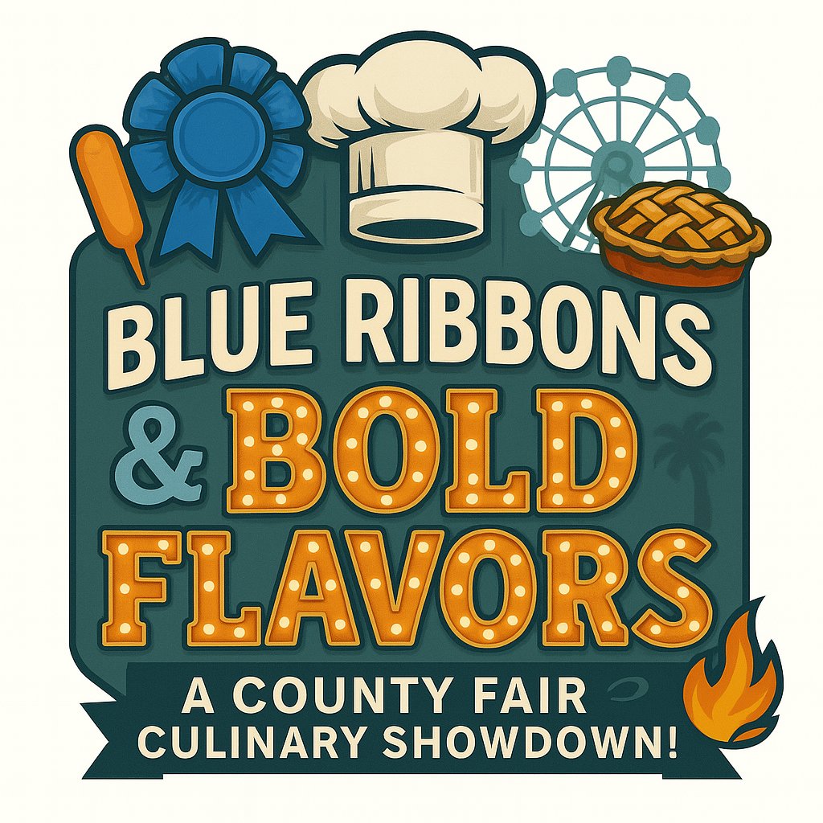
Monday, February 23, 2026
Proceeds Support
American Culinary Federation Flint-Saginaw Valley Chapter
Monday, February 23, 2026
Judging starts at 4:00 p.m.
Awards Ceremony at 7:45 PM
Doors open to the Public at 5:00 p.m. to 8:00 p.m.
Bavarian Inn Lodge – Frankenmuth, MI
Our culinary competition is open to all chefs, cooks, bakers, and pastry chefs who are members of the American Culinary Federation or work in an ACF House. An ACF House is defined as a food service facility with at least one active ACF member, in good standing, on its staff.

PLEASE READ CAREFULLY

There will be three savory categories and two baking categories.

Competitors can enter both the savory and baking categories.

Competitors are limited to 2 entries in total.

Competitors will be given a table (1) for all entries. Ex. Chef Z is competing in Cookie and Shrimp. Chef Z has one table for both entries.

SAVORY CATEGORIES

- POULTRY – Chicken Breast Fillets, Boneless Skinless, 6.5-7.5 Ounce, Raw
- SEAFOOD –Shrimp, Tiger, Shell-On, Headless, 31-40 Count per Pound, Raw, IQF
- PORK – Pork loin, 8 Pound Average

BAKING CATEGORIES

- PIE-Any type or kind
- COOKIE-any type or kind

GUIDELINES

- There is an entry form at the end of this packet. Please fill in all the information including a phone number, preferably a cell phone number where you can easily be reached.

- There is no entry fee required for competing chefs from an ACF House. ACF membership and sponsor support cover the cost of your entry. Your only out-of-pocket expenses will be the side dishes you may want to add to your presentation to enhance your entry and your table display.

- Disposable plates, napkins, and knives/forks/spoons will be provided for your samples to be served to the public.

- All competing chefs are responsible for their own equipment – knives, chafers, Sterno, cutting boards, etc. Don’t forget power strips and EXTENSION CORDS.

- Each competing chef is limited to Two ASSISTANTS to set up displays and get food ready for judging.

- A maximum of three wristbands will be issued to each competing team, one for the competing chef and one or two for the chef’s assistant(s). All other chef’s helpers must purchase admission.

- By entering our competition, you agree to allow ACF to use photos, videos, and recipes without further compensation or notice.

JUDGING

- The ACF Hot Food Competition organizing committee will select qualified judges. A minimum of one ACF Certified Chef will be assigned to each category. Judging panels may also include local celebrity foodie judges. A minimum of three judges will be assigned to each of the categories.

- The decision of the judges is final.

- The judging will be based on modified ACF hot food guidelines. Taste, texture, flavor, eye appeal, practicality, and nutritional balance are all considerations. A judging form is enclosed with this packet of information.

- Judging begins promptly at 4:00 p.m.

- Competitors will need to take one complete plate to the Judges room before the doors to the judging room will close at 4:00 pm. Chefs need to place a plate of one full size portion in the Judges room by their competitor number and leave the room. Judges will enter the room after all competitors leave and begin judging.

- Competitors will also need to provide a display plate and leave it on their table for the public to see the entry.

- Only judges and ACF event officials are allowed access to the judging room and Composer Rooms after 400 pm and during judging.

- AWARDS AND CASH PRIZES ANNOUNCED at 7:45 PM

- In the event of a tie in any of the food categories, Best Display Awards, and People’s Choice Awards, the individual display plate score will be used as the tiebreaker. The decision of the judges is final.

FOOD PREPARATION

- Bavarian Inn Restaurant will be the pick-up location for your proteins. You will be notified about one week in advance concerning when products will be available for pick-up. The contact is Chef Jacob Austin. Email chefjacobaustin@gmail.com

- Pie or Cookie Competitors
Butter Unsalted-8 pounds
All- Purpose Flour-20 pounds
Granulated Sugar –20 pounds
- Competing chefs will be required to produce one plated serving of their recipe for the judges to taste and one plated serving to be displayed and garnished on their table in the same manner as you would for service in your food service facility.

- Chefs will also be required to prepare their recipe to yield 400-500 one- or two-ounce tasting portions for our paying guests. Keep in mind that the tasting samples should be one or two bites and that the sample will be served on a disposable foam plate, with disposable plastic flatware to cut and eat the sample while standing.

- All competing chefs and their helpers must abide by the Michigan Department of Public Health guidelines – hot food hot/ and cold food/cold, use of gloves, hair restraints, etc. Failure to maintain temperatures will disqualify a competing chef.
- Limited kitchen space is available at Bavarian Inn Lodge on the day of the competition. We recommend that you do most, if not all, of your cooking off-premises before arriving at Bavarian Inn Lodge. Oven and warmer spaces are available on a “first come – first serve” basis. Call Chef Jason Wellnitz at 989 652-7200 if you need to use kitchen facilities. DEEP-FAT FRYERS ARE NOT ALLOWED IN THE DINING ROOMS – FRYERS ARE AVAILABLE IN THE KITCHEN AREA.

- The Bavarian Inn Lodge kitchen staff will not cook, prepare, or assist chefs with any of the food that is being judged or used as samples to the public.

- Chefs who do not have judge's plates ready by 4:00 pm will not be judged and will be disqualified from the People’s Choice award.
- All competing chefs are responsible for cleaning up their kitchen work area and dining room display area after the event.

TABLE DISPLAYS

- WE ENCOURAGE COMPETING CHEFS TO DECORATE THEIR TABLE BASED ON THE EVENING’S THEME –Blue Ribbons & Bold Flavors – “A County Fair Culinary Showdown”

- Bavarian Inn Lodge will provide each chef with one 8-foot table – draped in white skirting. Chefs may add or subtract from this linen set-up or opt to use their own skirting. No additional front table may be added to the display. A worktable or prep cart may be used, but these must be positioned behind your front table/main display table.
- Bavarian Inn Lodge dining rooms will be available for set-up at 1 p.m. on the date of the competition. The exact location of each chef’s table is determined by “luck of the draw” which will take place one week before the competition.
- ACF judging officials reserve the right to ask competing chefs to modify their displays to conform to fire, health, or safety codes. No umbrella or canopy tent-like structures, open flame tiki torches, or charcoal-fired grills will be allowed in the dining rooms due to smoke and fire concerns.

- All chefs and their helpers must wear double-breasted chef jackets of any color and toques. No baseball-style caps.

- Competing chefs are encouraged to promote their places of employment once the judging is completed, and the public enters the dining rooms. While judging, however, all references to your operation must be covered to allow for fair and unbiased “blind judging.”

PIE CATEGORY RULES
1. The person entering the contest must have made the pie from scratch, including the crust.
2. Two identical pies must be submitted for entry. One will be used as a display in the Composer room, and the other will go to the judge’s table.
3. You may choose to do any pie from any of the following,
• Cream - filling is cooked on the stove, then poured in precooked crust
• Fruit - filling is primarily fruit
• Custard - filling is poured into crust and baked in an oven
Chefs will also be required to prepare their recipe to yield 400-500 one- or two-ounce tasting portions for our paying guests. Keep in mind that the tasting samples should be one or two bites and that the sample will be served on a disposable foam plate

COOKIE CATEGORY RULES
1. The person entering the contest must have made the cookie from scratch.
2. Participants will present 6 cookies to the judges and provide a 6 cookie display plate in the Composer room.
3.You may choose to do cookie from any of the following
- Drop,
- Icebox
- Bar
- Cut out
- Pressed
- Rolled
- Molded
- Wafer
Chefs will also be required to prepare their recipe to yield 400-500 one- or two-ounce tasting portions for our paying guests. Keep in mind that the tasting samples should be one or two bites and that the sample will be served on a disposable foam plate

You will be provided with the above ingredients in the second week of February. Please contact
Chef Jacob Austin at 989 245-0075 to arrange to pick up your supplies. You will need to provide any additional items that you will need to make your pie or cookies and display items.
An 8ft table will be provided to you with linen on it to display your pie or cookie plate. An additional 8ft table will be behind for you to use as a workstation.
(If you need electricity, please let me know, and also remember an extension cord).
The table display is encouraged but not required to be made from edible items.
See Chef Lance Buchinger or Chef Jacob Austin if you have questions.

AWARDS
Gold and Silver awards will be presented in each of the five categories. Winners will receive commemorative plaques and cash prizes for their accomplishments.

“Best Display Award”
Gold and Silver awards plus cash prizes to the two top chefs who best use culinary techniques and artistry to represent the evening’s theme. Chefs are encouraged to use ice, sugar, pastry, chocolate, salt dough, tallow, and vegetable/fruit carvings to enhance their presentation.
“Peoples’ Choice Award”
The People’s Choice Award honors the chef who is the public’s favorite. The top vote-getter will receive a trophy and cash prize. Only fully paid guests will receive a ballot. Results will be announced at 7:45 p.m.

Gold and Silver Awards in Each of the Five Categories
GOLD 1st Place – Plaque & $250
SILVER 2nd Place – Plaque & $200
BEST DISPLAY OF SHOW
$250 and Four Post Trophy for 1st place
$200 and Three Post Trophy for 2nd place
All Event Judges Vote in This Category

PEOPLE'S CHOICE AWARD
$250 and Three Post Trophy
Only Paid Guests Receive a Ballot

All Competing Chefs and Assistants will Receive a Commemorative Medal with Neck Ribbon
Custom Designed for Our Event.

“Blue Ribbons & Bold Flavors”
A County Fair Culinary Showdown!

Monday, February 23, 2026

Chef’s Name: __________________________________________________________________

Address: ______________________________________________________________________

City: ______________________________________________ZIP: _______________________

Cell Phone: ___________________________ ACF # __________________________________

E-mail ________________________________________________________________________

Place of Employment: ______________________________________City__________________

Recipe Name or Names for Program: _______________________________________________
______________________________________________________________________________
______________________________________________________________________________

Name of Assistant #1 ____________________________________________________________

Name of Assistant #2 ____________________________________________________________

Categories: ___Chicken ___Shrimp ___Pork ___Pie ___Cookie

Recipe Name and Application must be emailed to Chef Lance Buchinger CSC.

Submit them as a Word Doc or a PDF.
Category slots are awarded on a first-come basis.
Applications must be 100% complete to be considered.

lancebuchinger@gmail.com Questions Cell: 989-450-1912

Judges Score Sheet for Entrée Categories
1 is the lowest and 10 is the highest

OVERALL COMPOSITION 1 2 3 4 5 6 7 8 9 10

Look at the tasting sample. Does it look appetizing? Is it something that you, personally, would order in a restaurant? Are the sauces/glazes smooth and silky? Are the various ingredients that make up the dish recognizable? Are the colors & tones appealing?

Judges’ Comments

TAST 1 2 3 4 5 6 7 8 9 10

Too much or too little salt, pepper, or seasoning? Are any off tastes present, i.e. burn, scorch, sour, bitter, metallic, or sharp? Are sauces, if any, smooth or are they greasy or fatty to the palate?

Judges’ Comments

TEXTURE 1 2 3 4 5 6 7 8 9 10

Are vegetables cooked al dente? Are the differing elements within the dish overcooked or undercooked? Are ingredients cut into proper sized pieces or are they too big/too small? Are sauces/coulis too thin/thick or grainy? Is “center of plate” meat tender to the bite?

Judges’ Comments

ORIGINALITY_1 2 3 4 5 6 7 8 9 10

Is the dish unique? Is there a creative or unusual use of ordinary ingredients? Is this similar or too close to standard restaurant fare?

Judges’ Comments

PLATE PRESENTATION 1 2 3 4 5 6 7 8 9 10

IN THE EVENT OF A TIE VOTE, THIS CATEGORY SCORE SERVES AS THE TIE BREAKER. Look at the displayed plate. Is this the way you would present it in your restaurant? Is the food sloppy on the plate. Does the food display “a picture in a frame”? Is the portion too big or too small? Is the display attractive and artistic?

Judges’ Comments
Judges Score Sheet for Pie Category
1 is the lowest and 10 is the highest

OVERALL COMPOSITION 1 2 3 4 5 6 7 8 9 10

Uniform attractive edges - Edges sealed well, no leaks - Blistery surface - Crust is close to filling,
Well blended; no clumps of starch - Filling is moist - Filling holds its shape. - Fruit filling did not leak from the crust

Judges’ Comments

TASTE 1 2 3 4 5 6 7 8 9 10

(of Filling & Crust) - Crust has a pleasant bland flavor which enhances fruit. – Filling is flavorful. – Components complement each other - Spices and flavorings add to the flavor of the filling

Judges’ Comments

TEXTURE & TENDERNESS 1 2 3 4 5 6 7 8 9 10

Crust cuts easily with a table knife or fork but holds shape when served. - Flakes layered throughout the crust

Judges’ Comments

ORIGINALITY_1 2 3 4 5 6 7 8 9 10

Is the pie unique? Is there a creative or unusual use of ordinary ingredients? Is this similar or too close to standard restaurant fare?

Judges’ Comments

PLATE PRESENTATION 1 2 3 4 5 6 7 8 9 10

IN THE EVENT OF A TIE VOTE, THIS CATEGORY SCORE SERVES AS THE TIE BREAKER. Look at the displayed pie. Would you buy this pie?

Judges’ Comments

Judges Score Sheet for Cookie Category
1 is the lowest and 10 is the highest Total of 40 Points

OVERALL COMPOSITION 1 2 3 4 5 6 7 8 9 10

Look at the tasting sample. Does it look appetizing? burnt edges? uniformed shape/size? Is it something that you, personally, would purchase? Are the colors & tones appealing?

Judges’ Comments

TAST 1 2 3 4 5 6 7 8 9 10

Good blend of flavors? Would you eat another one?) • Are any off tastes present, i.e. burn, scorch, sour, bitter, metallic, or sharp?

Judges’ Comments

TEXTURE 1 2 3 4 5 6 7 8 9 10

Is it appetizing to chew? Does it have the correct texture for the type of cookie?

Judges’ Comments

ORIGINALITY_1 2 3 4 5 6 7 8 9 10

Is the cookie unique? Is there a creative or unusual use of ordinary ingredients? Is this similar or too close to standard restaurant fare?

Judges’ Comments

PLATE PRESENTATION 1 2 3 4 5 6 7 8 9 10

IN THE EVENT OF A TIE VOTE, THIS CATEGORY SCORE SERVES AS THE TIE BREAKER. Look at the displayed plate. Is this the way you would present it in your restaurant?
Would you buy these cookies?

Judges’ Comments

